ISSS608 Visual Analytics and Applications
Timed Individual Assessment

DataVis Makeover is the process of redesigning existing data visualisation or dashboards to improve their clarity, effectiveness, and storytelling capacity. It focuses on applying best practices to make data easier to understand.

The Task
- Evaluate the data visualisation provided by identifying its strengths and weaknesses.
- Sketch a redesigned visualisation that improves the clarity, effectiveness, and storytelling of the original.
- Create the redesigned visualisation (DataVis Makeover) using Tableau Desktop.
- Describe the labour force participation trends and patterns reveal by the DataVis Makeover.

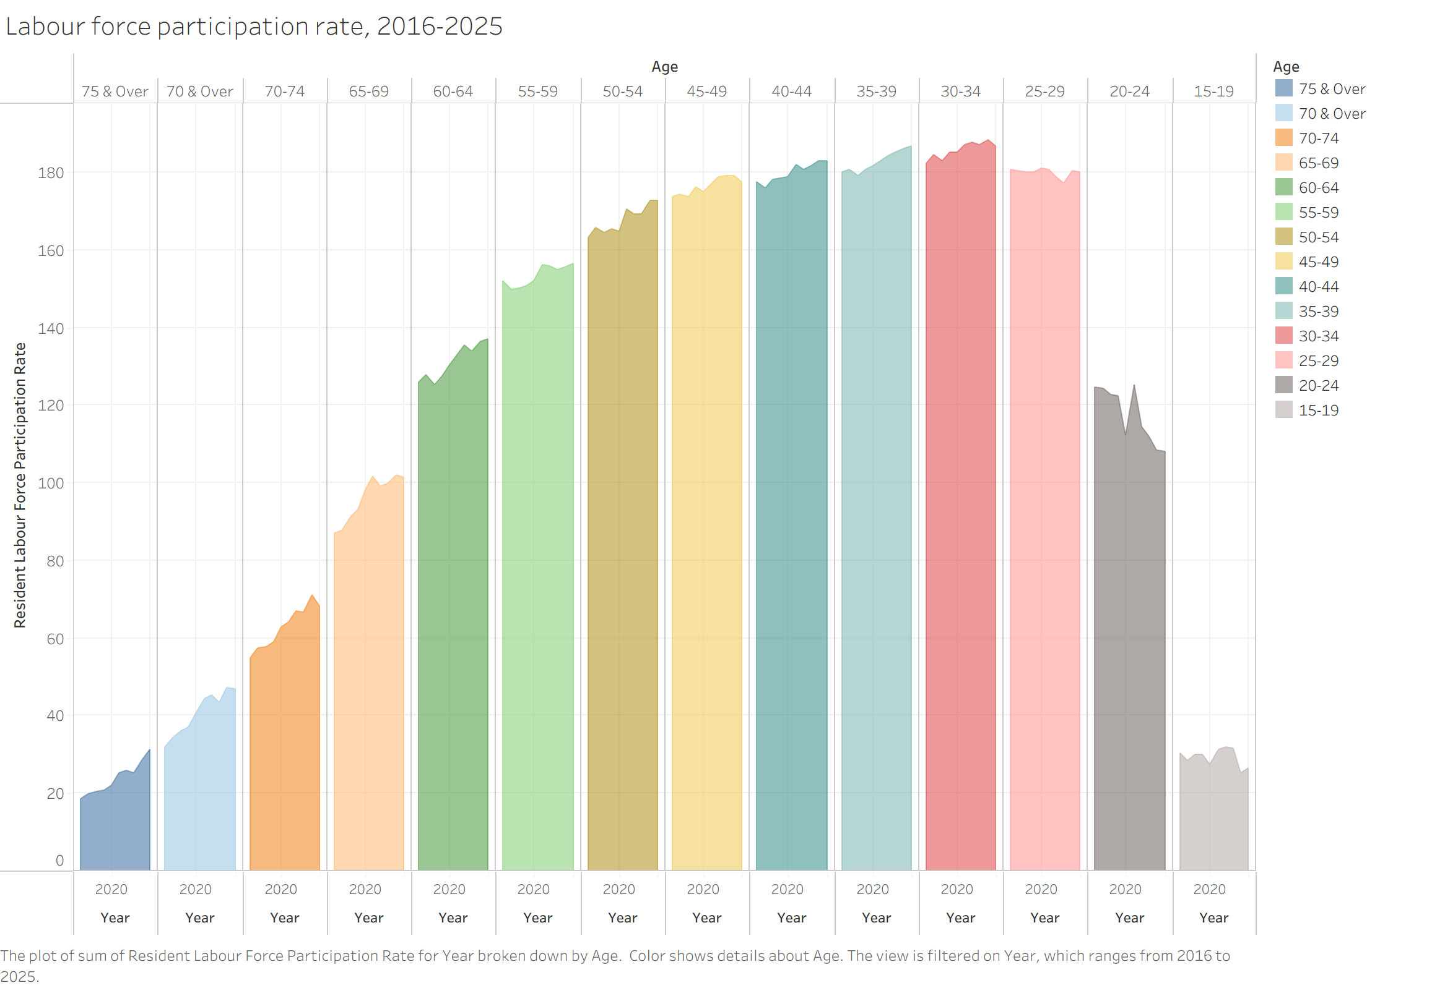

Submission Instructions
This is a timed individual assessment. You are required to complete the DataVis Makeover individually within 1 hour and 30 minutes during the class session.

- Write-up
You are required to submit a write-up in Microsoft Word format via eLearn. The write-up should include, but is not limited to, the following:
- At least three strengths of the original data visualisation.
- At least two weaknesses related to clarity and two related to aesthetic of the original data visualisation.
- A sketch of the redesigned visualisation, together with a brief explanation of how the redesign addresses the weaknesses identified in the original visualisation.
- At least five labour force participation trends and patterns revealed by the DataVis Makeover.

- Tableau Visualisation
Publish your DataVis Makeover on Tableau Public and submit the link via eLearn.

Assessment Rubic
Criteria | Excellent | Good | Satisfactory | Needs Improvement | Weights
Critique of Original Data Visualisation | Provides clear, insightful, and well-structured critique. Strengths and weaknesses are accurately identified and well justified using data visualisation principles. | Provides a logical critique with appropriate identification of strengths and weaknesses, with some supporting explanation. | Identifies some strengths and weaknesses but explanations are limited or partially unclear. | Limited or unclear critique. Strengths and weaknesses are poorly identified or unsupported. | 20%
Redesign Proposal (Sketch & Explanation) | Redesign sketch is clear and well thought out. Explanation clearly shows how the new design addresses the weaknesses and improves clarity and storytelling. | Redesign is reasonable and addresses most weaknesses. Explanation is generally clear. | Redesign addresses some weaknesses but explanation lacks clarity or completeness. | Redesign is unclear or does not meaningfully address the weaknesses identified. | 20%
Implementation Using Tableau Desktop | Tableau visualisation is well designed, clear, and visually effective. Appropriate chart types, layout, labels, and formatting are used. | Tableau visualisation is generally clear with appropriate chart type and layout, with minor issues. | Tableau visualisation is functional but contains several clarity or formatting issues. | Tableau visualisation is incomplete, difficult to interpret, or poorly implemented. | 25%
Visual Storytelling and Insight Communication | Provides clear and insightful interpretation of trends and patterns revealed by the DataVis Makeover. Insights are well articulated and supported by the visualisation. | Describes key trends and patterns with reasonable clarity, though explanation may lack depth. | Identifies some trends or patterns but explanation is limited or partially unclear. | Little or no meaningful interpretation of the trends or patterns shown in the visualisation. | 20%
Bonus: Creativity & Storytelling | Demonstrates exceptional creativity, strong visual hierarchy, and compelling storytelling. | Shows good creativity and visual improvement over the original design. | Shows limited creativity but improves some aspects of the original visualisation. | Little or no improvement in creativity or storytelling. | 15%

